

bABALWA mPUNYUKA- PRACTICAL ACTIVITY

Babalwa.mpunyuka@womentechsters.org



May 28, 2021

WOMEN TECHSTERS

1. The deployment of a Windows Server 2016 Gen 1 was successful.

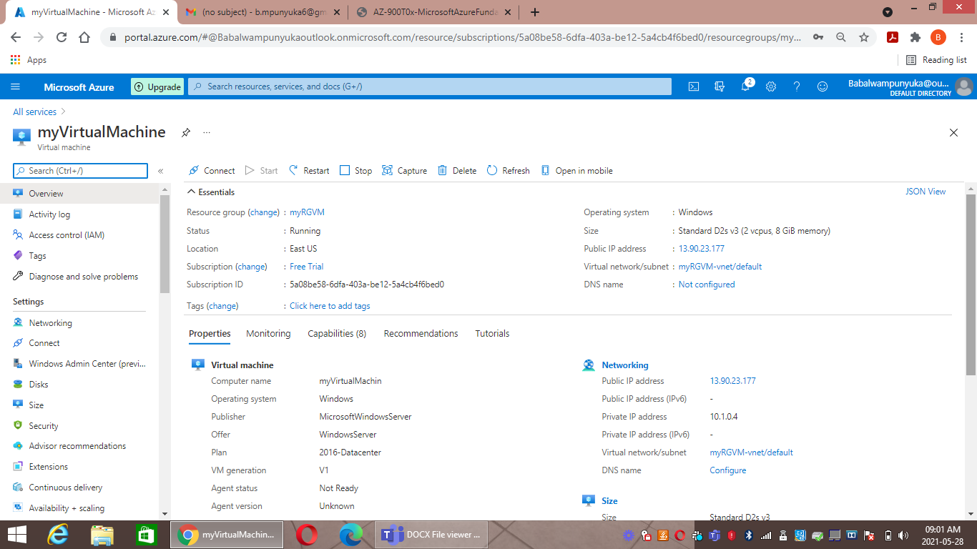

1. Installation of the windows feature- Web server management tools was deployed successfully and the browser was confirmed.

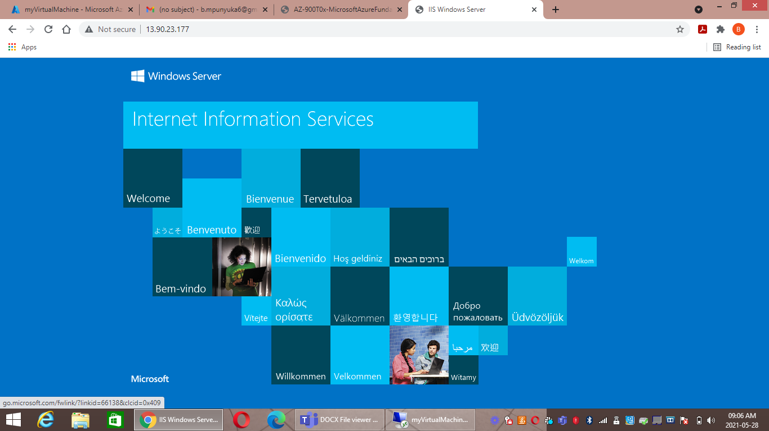

1. The site recovery vault was created and the windows server was added to the replicated items in the Recovery Service Vault to be tracked.

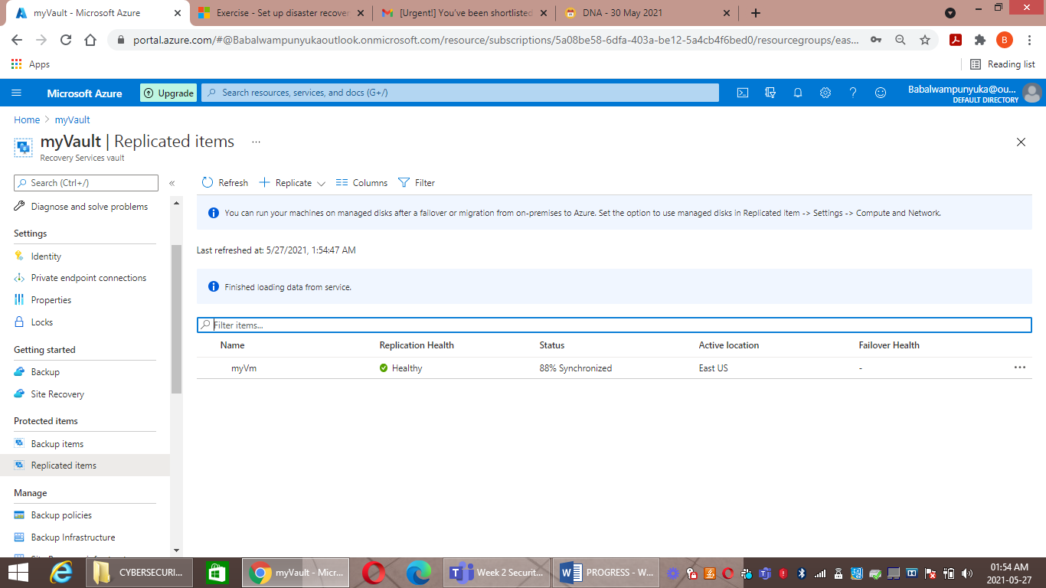

1. 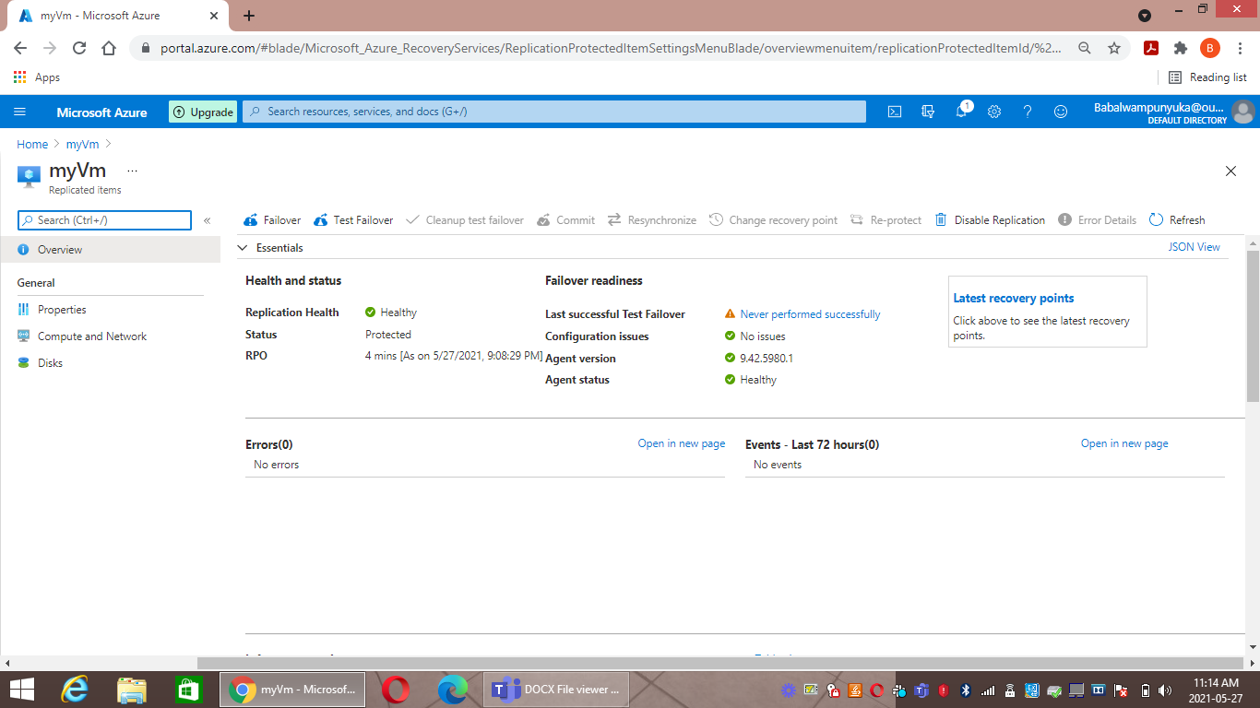The windows server stopped to assume the breakdown.

1. Performing a Test Failover for the windows server. 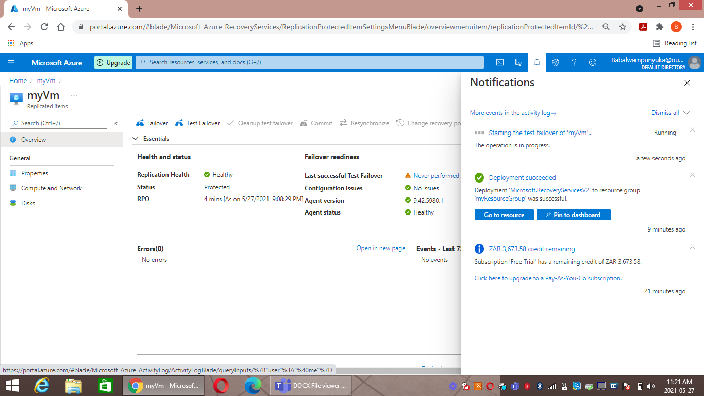
2. The Failover is in process.

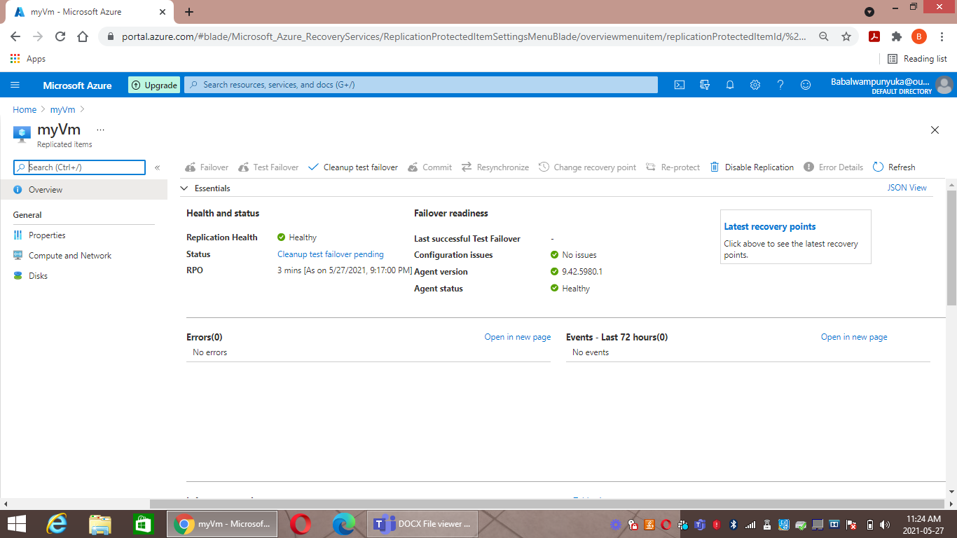

1. The Failover was deployed successfully.

